

Design of an AM receiver

ECSE 434

Micro Electronics Lab

4.2 Lab Preparation - Preamplifier

Sharhad Bashar, *260519664*

Chrouk Kassem, *260512917*

Zixuan Yin, *260502051*

Wednesday, 11th November, 2015

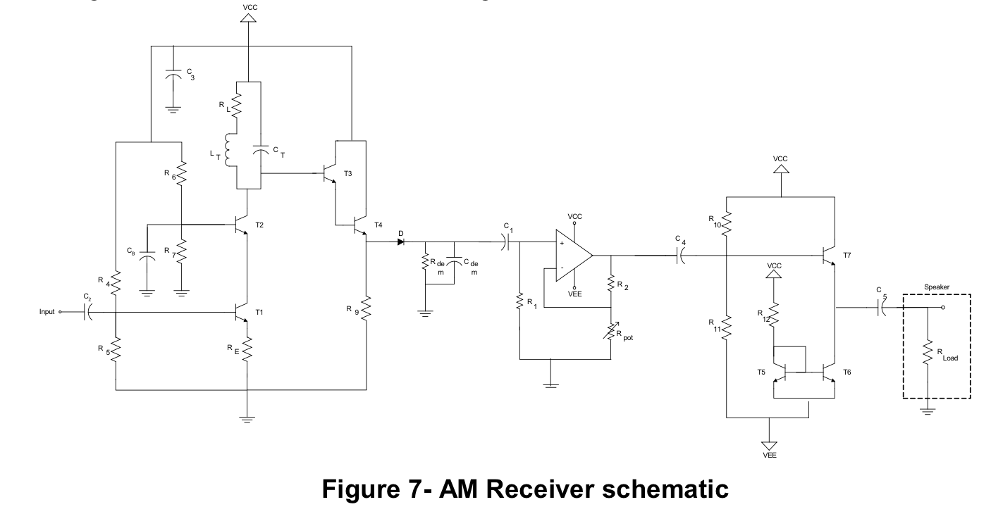

**5.1.1. Simulate the whole system in SPICE using a multiplier to create your AM modulated input. Provide a plot of the output signal and of the input signal, so that the modulation and demodulation are apparent.**

Upon completion of the simulation, the following graphs were produced:

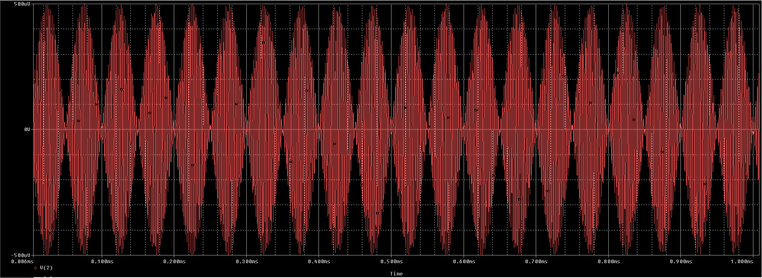

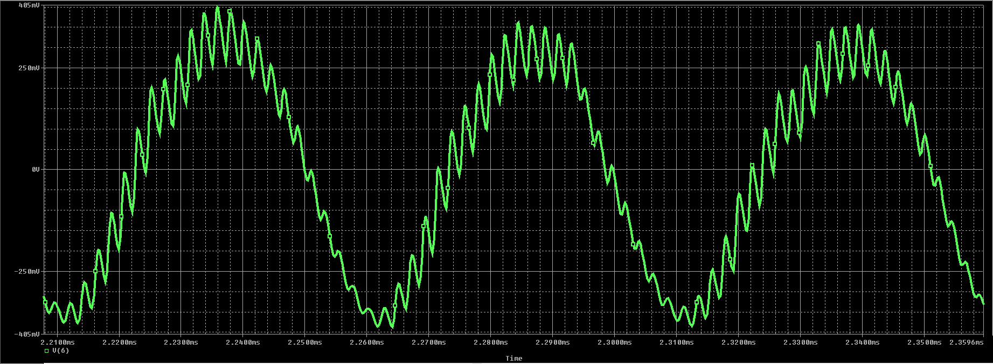

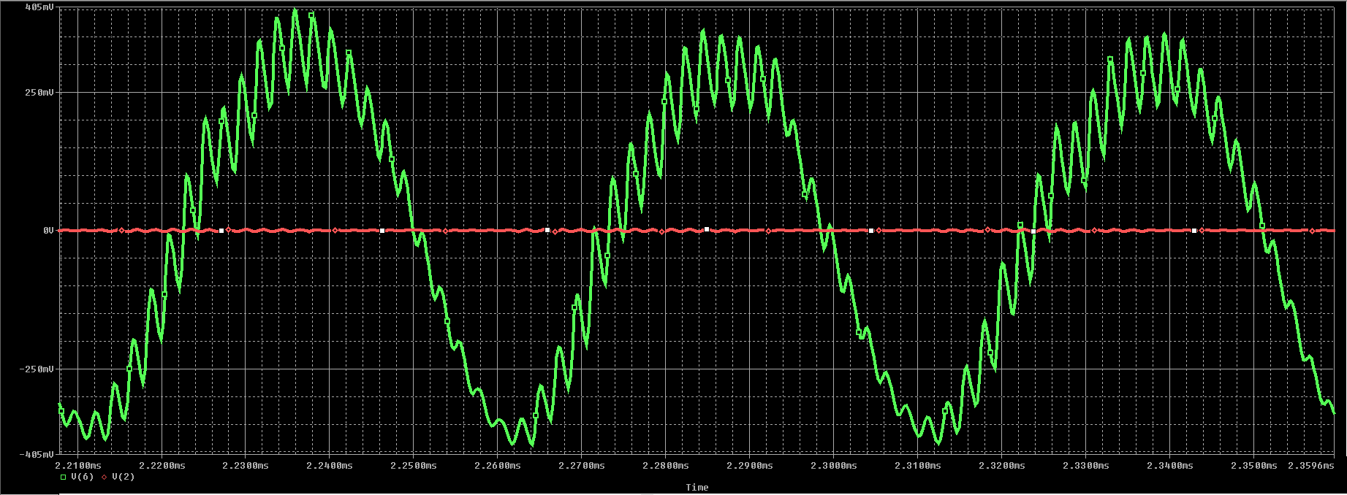

The first diagram in red shows the input, a modulated signal, with amplitude of 500uV.

The second graph shows the output, with amplitude of 500mV

And lastly, the third image shows the input and the output together.

The gain of the circuit is therefore 500mV/500uV = 1000 V/V

**5.1.2. Discuss the effect of loading between each sub-system in the receiver path on performance.**